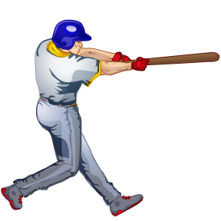( approved 03/01/19 )
Minors – 7 & 8 yr old (Pitching Machine)

Offense: Each team is allowed three coaches inside the fenced area during offensive play; one coach on first base, one coach on third base, and one coach at the pitching machine. The coach at the pitching machine may not communicate with the base runners. One additional coach must be present in the dugout at all times.
Defense: One coach is permitted to stand in front of the dug out.

1. After 3 outs or 10 batters, teams will switch offense. All players on a team will bat in a continuous batting order. Players arriving late will be entered at the end of the batting order. Injured players will not result in an Out in the batting order.
2. Batters will be called out after five (5) pitches or (3) strikes. Batters that foul the ball on the fifth pitch will receive additional pitches as long as pitches are fouled off. Umpire decision if ball is declared not hittable.
3. Games will be five innings or 1 hr 15 minute time limit. No new innings will start after 1 hr 10 minutes. Tied games will end in a tie.
4. Any batted ball that hits the pitching machine will be a dead ball and all runners will advance one base.
5. No intentional bunting or stealing is allowed.
6. To stop play the ball must be in front of the lead runner or the runner stops forward motion. Players between bases will advance at the discretion of the umpire. A 12 foot diameter circle will be used for pitching area.
7. The catcher is required to wear all catchers’ equipment, with a throat protector during every practice and game. This includes a cup.
8. Each team is required to have a competent score keeper at each game. The home team’s book is the official book.
9. A team must have eight (8) players present to start or continue a game. Defense will use 10 players, including catcher and four outfielders. Each player is required to play one of the first (3) innings on defense.
10. A batter will be called out if he/she slings the bat in a dangerous manner. The first occurrence involving a batter slinging a bat will result in a verbal warning to each team by the umpire. Any further violations by either team will result in the batter being called out.
11. The infield shall consist of a regulation infield. All other members of the defensive team must be in the grass of the outfield.
12. Ejections:
i. 1st offense- one game suspension
ii. 2nd offense- reviewed by the League Board
13. A mandatory courtesy runner may be used for catcher if he or she is on base with two outs. The runner must be the player who made the last out.
14. No infield fly will be called.
15. No head first sliding.
16. Once a player has taken a position on defense, that player may not change positions during that inning. The player may play a different position the next inning.
17. Departments should make very effort to have the baseball umpires properly trained and looking professional.
18. Pitching machine setting: 40 mph from 42 feet
19. Players must wear batting helmets with chinstrap and facemask while batting, base running, and ON DECK.
20. Defensive player in position of the pitcher must wear a batting helmet during the game.
21. The Coach putting the ball into the pitching machine must rotate off the field when possible (away from the ball) after the ball is hit.
22. Regular ‘hard’ baseball will be used.

